DEGREE OF COMPARISON

**A. Definisi Degree of Comparison**

*Degree of Comparison* adalah *sebuah bentuk perbandingan yang digunakan menyatakan tingkat perbandingan sifat atau perilaku antara orang dengan orang lain ataupun benda dengan benda lainnya*. Tujuannya adalah untuk mengetahui hasil atau kualitas dari hal yang kita bandingkan tersebut. Dalam hal ini, Degree of Comparison terbagi menjadi tiga jenis. Yakni,

1. Positive Degree (tingkat biasa) : (*tall)* for example : I am 165 cm tall

2. Comparative Degree (tingkat lebih) : (*tall + er)* for example : I am taller than him

3. Superlative Degree (tingkat paling) she is smartest of all/them : (tall + est.) for example : He is tallest than Me and Him (conclusion : He is tallest of all/of them

**B. Jenis Degree of Comparison**

**Positive Degree** merupakan bentuk kalimat perbandingan yang menjelaskan sifat yang sama antar dua benda atau orang. Dalam hal ini, tidak ada hal yang membandingkan atau perbandingan satu sama lain karena sifat keduanya sama, misalnya ***secantik, sepintar, serajin, setinggi, seumuran*** dan lain-lain.

**RUMUS :**

As tall as (setinggi/sama tinggi)

**Subject 1 + tobe (is, am, are) + AS + adjective + AS + Subject 2**

**Contoh:**

1. George is 167 cm (tall) Jimmy is 167 cm (tall)

**Jadi :**

George is as tall as Jimmy

*(George setinggi Jimmy)*

*Adverbs consisted are; * Adverb of time 08.00 am tomorrow, yesterday, place (at the beach, in the room, at the land etc, manner: fast****ly****, quick****ly****, short****ly****, smart****ly****,*

2. Jimmy is as tall as George

*(Jimmy setinggi George)*

3. *Maya is 17 years old (old)*

4. *Indah is 17 years old (old)* ***Jadi : (conclusion)***

1. *Maya is* ***as old as*** *Indah*

2. *(Maya* ***seumuran*** *Indah)*

3. *Indah is* ***as old as*** *Maya*

(*Indah* ***seumura****n Maya*)

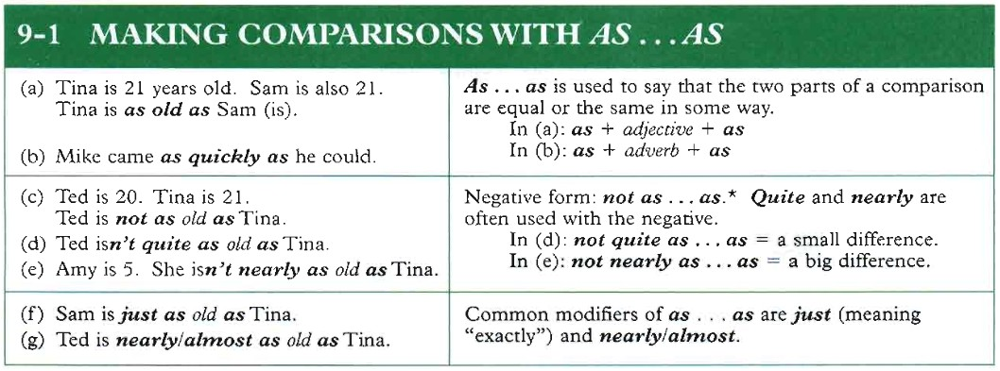

Tabel 9 Perbandingan dengan Menggunakan as…as

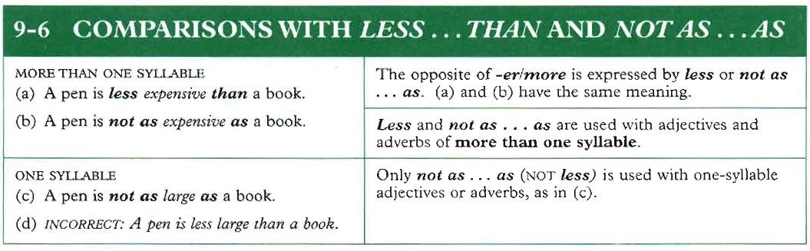

Tabel 10 Perbandingan dengan Menggunakan *Less…than and not as…as*

Syllable : suku kata, one Syllable hot + hotter+hottest+ large + largest smart+smarter+smartest  
two Syllable,:   
three Syllable : Di-li-gent (diligent), expensive ; ex-pen-sive, bri-li-ant (

Comparative degree merupakan bentuk perbandingan yang digunakan untuk membanding sifat yang lebih diantara dua benda atau orang. Jadi ada diantara dua benda itu yang mempunyai sifat yang lebih menonjol, seperti lebih pintar, lebih panas, lebih sibuk, lebih cantik, lebih tua dan lain-lain. Dalam hal menyatakan tingkatan lebih ada caranya yaitu dengan penambahan ***“er”***setelah kata yang bersuku kata 1/2. Pemberian “**more”** sebelum kata yang bersuku kata lebih dari dua. Dan untuk menyatakan ***“dari”***kita menggunakan ***“than”***

**Kata sifat yang bersuku kata 1/2 Kata sifat yang lebih dari 2 suku kata**

|  |  |  |  |
| --- | --- | --- | --- |
| Cold | : colder than | Beautiful | : more beautiful than |
| Hot | : hotter than | Difficult | : more difficult than |
| Old | : older than | Diligent | : more diligent than |

**RUMUS :**

**Subject 1 + tobe + ( adjective + er ) + than + Subject 2 (more + adjective)**

**Contohnya:**

• Ilham gets up at 04.55 a.m (dilligent) (lazy) Tasya gets up at 05.20 a.m (dilligent) (lazy)

Ilham dan Tasya mempunyai perbedaan sifat dilihat dari waktu bangun pagi jadi kita bisa membandingkan 2 sifat diantara mereka.

• Ilham is **more diligent than** Tasya

*(ilham lebih rajin dari pada Tasya karna bangunnya lebih awal)*

• Tasya is l**azier** than Ilham

*(Tasya lebih malas dari pada Ilham karna dilihat waktu bangun tidur lebih siang)*

• Emmy runs in 3 minutes (fast,slow,long,short) Dicka runs in 5 minutes (fast,slow,long,short)

(Emmy dan Dicka dalam lomba lari mempunyai waktu yang berbeda, bisa **disimpulkan** sifat yang disoroti lebih cepat/ lebih pelan dan lebih lama/lebih singkat)

• Emmy is **faster** than Dicka

*(Emmy lebih cepat dari pada Dicka)*

• Dicka is **slower** than Emmy

*(Dicka lebih pelan dari pada Emmy)*

• Dicka is **longer than** Emmy in Running

*(Dicka lebih lama dari pada Emmy dalam hal lari)*

• Emmy is **shorter** than Dicka

*(Emmy lebih singkat dari pada Dicka dalam hal lari)*

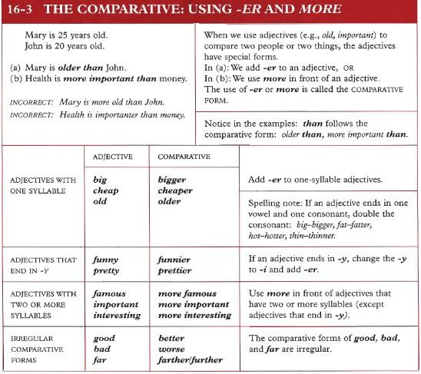

**Tabel 11 Perbandingan dengan menggunakan –*er* dan *–more***

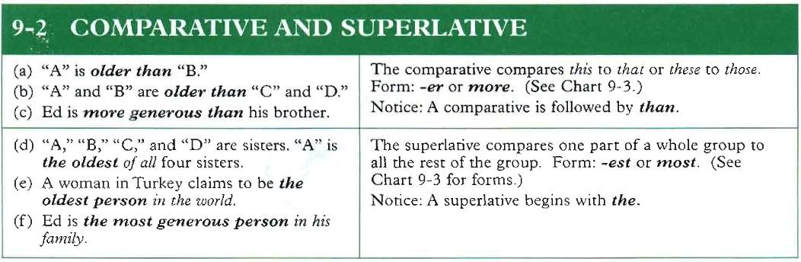

Tabel 12 Perbedaan antara penggunaan *Comparative* dan *Superlative*

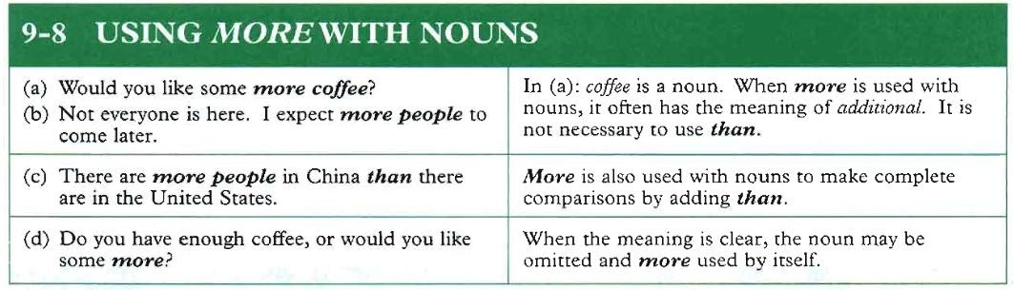

✓ Superlative Degree digunakan untuk menyatakan sifat yang paling menonjol (terlihat) diantara semua (lebih dari dua benda). nah untuk menyatakan tingkatan paling ada caranya yaitu dengan penambahan “est” setelah kata yang bersuku

Tabel 13 Penggunaan *more* dengan *nouns*

*Noted:*

kata 1/2. Pemberian “the most” sebelum kata yang bersuku kata lebih dari dua.

Perhatikan table dibawah ini

**Kata sifat bersuku kata 1/2 Kata sifat bersuku kata lebih dari 2**

Warm : the warmest Charming : the most charming Big : the biggest Interesting : the most interesting Tall : the tallest Famous : the most famous

**RUMUS :**

**Subject + tobe + (the adjective + est) (the most adjective)**

**Contoh :**

**• Antonio gets 100 in math, 79 in social and 87 in art.**

**• Ann gets 92 in math, 89 in social and 95 in art.**

**• Donald gets 75 in math, 95 in social and 77 in art.**

*(Diantara nilai Matematika, IPS dan kesenian Mario, Ann dan Zio terdapat nilai yang berbeda, disimpulkan ada nilai yang tertinggi dan terendah)*

• Antonio‟s score is the highest in math

***(Nilai Antonio adalah yang paling tinggi di pelajaran Matematika)***

• Donal‟s score is the lowest in math

***(Nilai Donal adalah yang paling rendah dalam pelajaran Matematika)***

• Donal‟s score is the biggest in social

***(Nilai Donal yang paling besar dipelajaran IPS)***

• Antonio score is the smallest in social

***(Nilai Antonio yang paling kecil di pelajaran IPS)***

• Ann‟s score is the largest in Art

*(Nilai Ann yang paling besar di pelajaran Kesenian)*

• Donal‟s score is the smallest in the art

*(Nilai Donal yang paing kecil dipelajaran Kesenian)*

• Baturaja has 2 department stores

• Jakarta has 130 department stores

• Palembang has 10 department stores

*(Diantara kota Baturaja, Jakarta, dan Palembang, disimpulkan bahwa kota Jakarta adalah kota yang paling modern dibidang perekonomian karena mempunyai banyak pusat perbelanjaan)*

• Jakarta is the most modern city in trade center among Baturaja and Palembang.

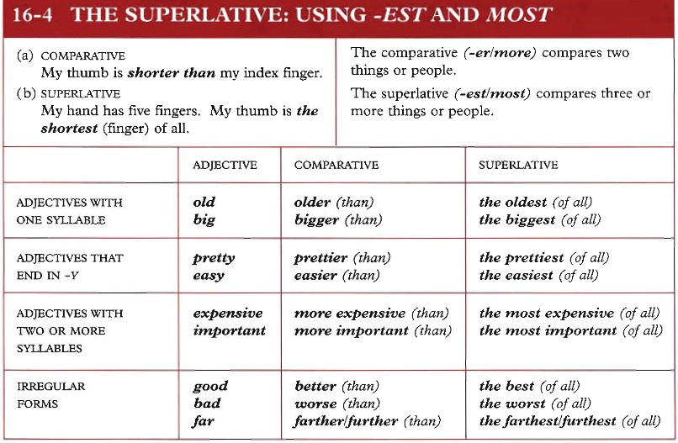

Tabel 14 *Superlative:* penggunaan *–est* dan *most*

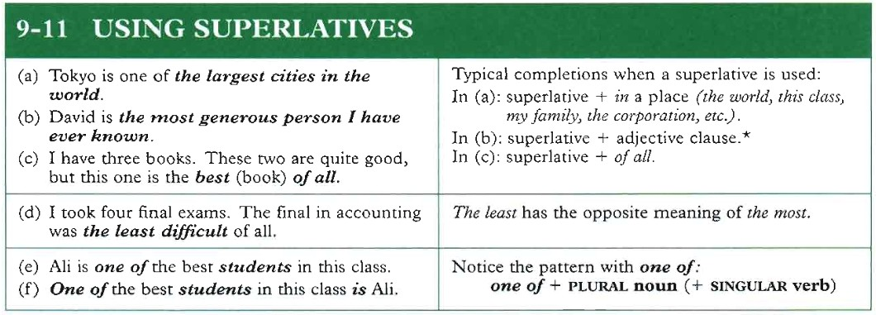

**Tabel 15 Penggunaan *Superlative***

Ada sejumlah kata sifat *(adjective)* yang mengalami perubahan bentuk, untuk lebih jelas perhatikan table dibawah ini.

|  |  |  |  |
| --- | --- | --- | --- |
| **Positive**  Good/well | **Arti**  Baik/bagus | **Comparative**  Better | **Superlative**  Best |
| Far | Jauh | Farther / further | Farthest/ furthest |
| Bad /ugly / ill | Jelek/buruk/sakit | Worse | Worst |
| Little/ a few/ a little | Sedikit | Less | Least |
| Old | Tua | Older/ elder | Oldest/ eldest |
| Much/ many | Banyak | More | Most |
| Nigh | Dekat | Nigher | Nightest/ next |
| Hind | Belakang | Hinder | Hindmost |
| Few / little | Kecil | Less | Least |
| Late | Telat | Later | Last |
| Up | Atas | Upper | Uppermost |
| Early | Awal | Earlier | Earliest |
| Late | Terakhir | Later | Latest |
| Smart | Pintar | Smarter | Smartest |
| Lazy | Malas | Lazier | Laziest |
| Fast | Cepat | Faster | Fastest |

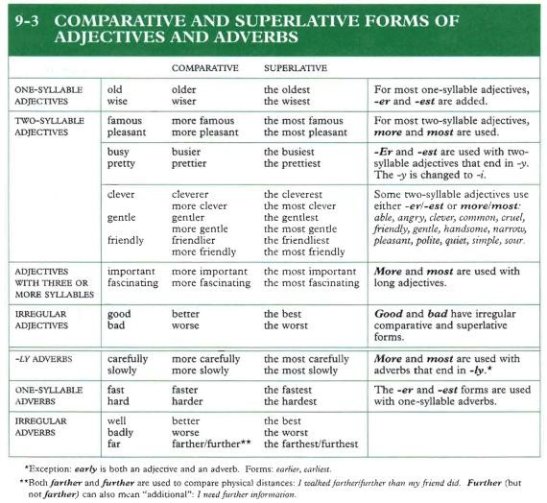

**Tabel 16 *Comparative and Superlative Forms of Adjectives and Adverbs***

WH-QUESTIONS

**A. Definisi *Wh-Questions***

*Information Questions (Wh-Questions* dan *how)* adalah bentuk pertanyaan yang menanyakan informasi dengan menggunakan *Question Words* (kata tanya). Sering disebut dengan *Wh-question* karena semua kata tanya diawali dengan *Wh-*, kecuali *How*. Yang termasuk *Question Words (QW)* adalah: *What, Who, Whom, Whose, Why, Where, When, Which* dan *How.* Karena *Questions Words* ini terdiri dari 9 buah kata tanya, oleh karena itu kata tanya ini lazim disebut 8W+1H.

**B. Perbedaan *Yes-No Questions* dengan *Information Questions***

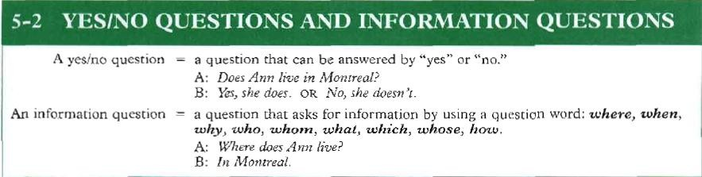

Gambar 1 Perbedaan *Yes-No Questions* dengan *Information Questions*

Dari gambar diatas terlihat jelas perbedaan antara *Yes-No Questions* dengan *Information Questions,* dimana *yes/no questions* merupakan bentuk pertanyaan yang dapat dijawab dengan jawaban *Yes* atau *No*, sementara *information questions* adalah bentuk pertanyaan yang bertujuan untuk menanyakan informasi dengan menggunakan kata tanya (*question word),* yaitu *where, when, why, who, whom, what, which, whose,* dan *how* (Azar, 2003:123).

**C. Macam-macam, fungsi, dan contoh *Wh-Questions***

|  |  |  |  |
| --- | --- | --- | --- |
| **No.** | **Wh-Questions** | **Fungsi** | **Contoh** |
| 1. | What (apa) | Menanyakan **nama benda,**  **nama orang atau jenis profesi.** | 1. Question: What is that?  Answer: That is an apple.  2. Question: What are you?  Answer: I am a soldier.  3. Question: What is your name? Answer: My name is Ivanka. |
| 2. | Who (siapa) | Menanyakan orang  sebagai pelaku/*subject*. | 1. Question: Who are you?  Answer: I am Joko Pinurbo.  2. Question: Who writes the letter?  Answer: Martin does.  3. Who is very beautiful?  Answer: Agnes Monica is very beautiful. |
| 3. | Whom (siapa) | Menanyakan orang  sebagai *object*. | 1. Question: Whom do you meet?  Answer: I meet Inul Daratista.  2. Question: Whom is she looking for?  Answer: She is looking for Brian Safina. |
| 4. | Whose (milik  siapa) | Menanyakan pemilik suatu  benda. | 1. Question: Whose bag is this?  Answer: This is my bag  2. Question: Whose sister is the girl?  Answer: She is my sister |
| 5. | Why (mengapa) | Menanyakan alasan atau  penyebab terjadinya sesuatu. | 1. Question: Why do you come late?  Answer: Because I missed the bus this morning  2. Question: Why is Mrs. Julia very  healthy?  3. Answer: Because she does sport every morning.  4. Question: Why do you love me?  5. Answer: Because you are very rich. |
| 6. | Where (dimana) | Menanyakan tempat. | 1. Question: Where does Alicia study?  Answer: She studies in SMPN 03  Wonogiri.  2. Question: Where do you go every day?  Answer: I go to school every day.  3. Question: Where is the library?  Answer: The library is beside the hall. |
| 7. | When (kapan) | Menanyakan waktu. | 1. Question: When does Alfian get up?  Answer: He gets up at five o‟clock every  morning.  2. Question: When did you go to Eromoko?  Answer: I go to Eromoko last week.  3. Question: When do you go to school?  Answer: I go to school at 06.30. |

2

|  |  |  |  |
| --- | --- | --- | --- |
| 8. | Which (yang  mana) | Menanyakan pilihan. | 1. Question: Which is your car?  Answer: My car is the red one.  2. Question: Which is his sister?  Answer: His sister is the girl with the blue jacket. |
| 9. | How  (Bagaimana) | Menanyakan kondisi atau  keadaan. | 1. Question: How are you?  Answer: I am fine. Thanks.  2. Question: How is Reyna‟s school?  Answer: Her school is large and clean. |

Tabel 1 Macam-macam, fungsi, dan contoh *Wh-Questions*

**D. Penjelasan tambahan mengenai *who, whom,* dan *how.***

1. Who (Siapa, sebagai subjek)

a. Who digunakan untuk menanyakan orang (sebagai subjek). Contoh kalimatnya bisa Anda lihat di bawah ini:

1. Who is that? [Siapa itu?]

2. Who is going to come with Messi? [Siapa yang akan datang dengan

Messi?]

3. Who is she dating now? [Siapa yang sedang dia kencani sekarang?]

4. Who can help me bring this table? [Siapa yang bisa membantu saya membawa meja ini?]

5. Who were you calling? [Siapa yang sedang Anda telepon?

6. Who will you invite to the party? [Siapa yang akan Anda undang ke pesta?]

b. Selain itu, ***who juga bisa langsung diikuti oleh kata kerja.*** Perhatikan contoh- contohnya di bawah ini:

1. Who wants to eat? [Siapa yang mau makan?]

2. Who cares? [Siapa yang peduli?]

3. Who won the match? [Siapa yang memenangkan pertandingan?]

4. Who wrote the Harry Potter? [Siapa yang menulis Harry Potter?]

2. Whom (Siapa, sebagai objek)

Berbeda dengan *who*, *whom* digunakan untuk menanyakan orang sebagai objek. Contoh kalimatnya dijelaskan pada gambar 2 sebagai berikut:

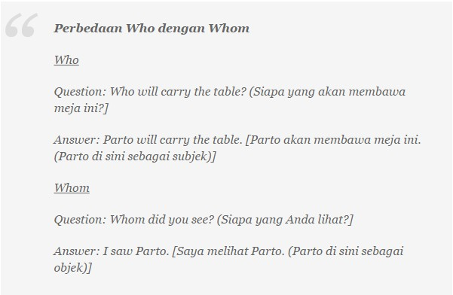

Gambar 2. Perbedaan *who* dengan *whom*

3. How (Bagaimana, Berapa, Seberapa)

How biasanya digunakan untuk menanyakan cara, kondisi/kualitas, kabar/kesehatan seseorang, jumlah ([yang dapat dan tidak dapat dihitung),](http://www.tipsbelajarbahasainggris.com/kata-benda-yang-dapat-dan-yang-tidak-dapat-dihitung/) usia, jarak, durasi, dan frekuensi. Contoh kalimatnya adalah sebagai berikut:

a. How does the washing machine work? [Bagaimana cara kerja mesin cuci?]

b. How was your exam? [Bagaimana ujian Anda?]

c. How are you? [Bagaimana kabar Anda?]

d. How many children does Parto have? [Berapa banyak anak yang Parto miliki?]

e. How much money have you spent this month? [Berapa banyak uang yang telah Anda habiskan bulan ini?]

f. How old are you? [Berapa usia Anda?]

g. How far is Bali from Jakarta? [Seberapa jauh Bali dari Jakarta?]

h. How long can you go? [Berapa lama Anda bisa pergi?]

i. How often do you visit your grandmother? [Seberapa sering Anda mengunjungi nenek Anda?]

**E. Tips membentuk/membuat *Wh-Questions***

Yang perlu diingat dalam membentuk/membuat *Wh-Questions* adalah:

1. Bentuk waktu (tense).

2. Memiliki main verb atau tidak? Jika memiliki main verb, gunakan formula

**QASM** (Question word, [Auxiliary verb,](http://www.tipsbelajarbahasainggris.com/4-jenis-kata-kerja-bantu-yang-harus-anda-kuasai/) Subject, Main verb).

3. Disertai keterangan atau tidak?

Untuk lebih jelasnya, silahkan lihat tabel di bawah ini:

|  |  |  |  |  |  |
| --- | --- | --- | --- | --- | --- |
| **Tense** | **Question word** | **Auxiliary verb** | **Subject** | **Main verb** | **Keterangan** |
| **Simple**  **Present** | What | Does | Sarah | think | about the project? |
|  | What | Is | your name? | – | – |
|  | What | Are | You | doing? | – |
|  | What | Would | You | do | if you have a million dollars? |
|  | Where | Are | You | – | now? |
|  | Why | Do | You | love | me? |
|  | Who | Is | she? | – | – |
|  | How | Does | the washing machine | work? | – |
|  | How many kids | Do | You | have? | – |
| **Simpe Past** | What | Did | You | do | yesterday? |
|  | When | Did | You | create | the blog? |
|  | Where | Did | You | buy | that T-shirt? |
|  | Why | Were | You | late? | – |

Tabel 2 Cara Membuat *WH-Question* di dalam suatu kalimat

F. Exercises

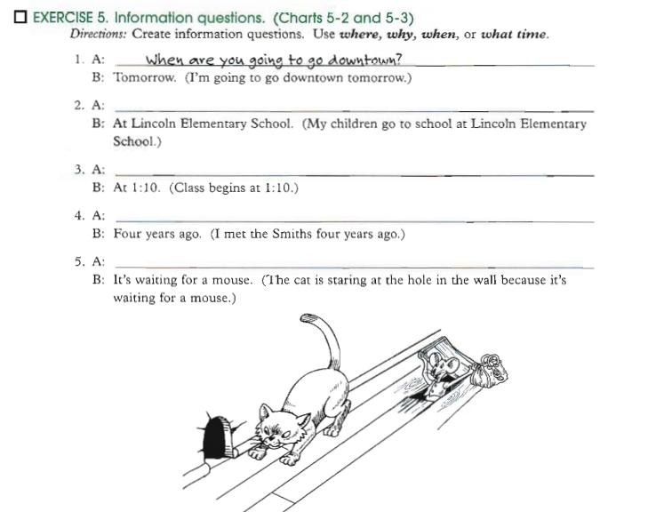

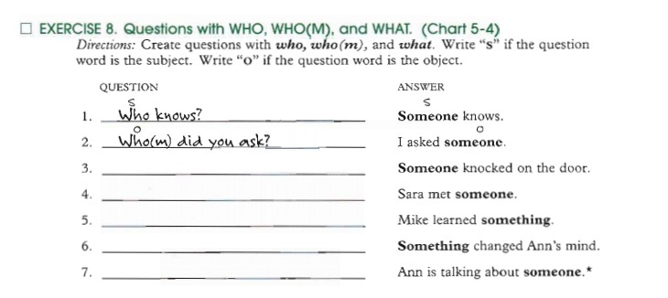

6

I

II!) EXERCISE9. Questions with WHO, WHO(M), and WHAT. (Chart 5-4)

*Directions:* Create questions. Use *1.~ho, whom,* or *what.*

l. A· Wbet e,iJ- :yo\A see?

B: An accident. (I saw an sccideru.)

2. A· What Did Mary see?

B· An accrdent, (Mary saw an accidenr )

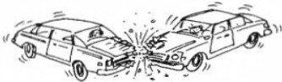

*WHO WHAT*

3. A: Who saw the accident ?

B: Mary. (Mary saw an accidenr.)

-l. A.

B· John. (Mary saw John.)



*WHO* W~O(M)

•A pn-s-,uon may come •• lhc bq;~ of a qucsuon "' YCT) fonNI Enp1sh•

"""°"'

*Abotl1* (NOT .... o) t1 *A"" ~J*

In ~ EnsJHh,*a* prq,osuioo usually don no, c.omc •• the bcprvuna *oC •* quauon.

5. A: B: Mary. (Mary saw John.)

6. A:

*B:* An accident. (An accident happened.)

7. A:

8. A new coat. (Alice bought a new coat.)

8. A: B: Alice. (Alice bought a new c oar.)

9. A: B: A map of the world. (J>rn looking at a map of the world.)

i o. A:

B: Jane. (I'm looking at Jane.)

11. A: B: 'Tbe secretary. (I talked to the secretary.)

12. A: What did talked about ? B: His problems. (Tom talked about his problems.)

13. A: B: Tile board. (The teacher looked at the board.)

14. A:

B:

15. A:

B:

The teacher. (nle teacher looked at the board.)

- --- -----------------------------------

The st:udeots. (The teacher looked at the students.)

**Pronouns**

|  |  |  |  |  |
| --- | --- | --- | --- | --- |
| Subject | Adjective | Object | Possessive | Reflexive |
| I | my | me | mine | myself |
| you | your | you | yours | Yourself |
| he | his | him | his | Himself |
| she | her | her | hers | Herself |
| it | its | it | it | Itself |
| we | our | us | ours | Ourselves |
| they | their | them | theirs | Themselves |

Note :

Fatima has two brothers – they are her brothers-they are hers-they’re fatima’s brother.

Haris has an uncle – he is his uncle – he’s his - He is Haris’ uncle.

**Task One**

*Copy out the sentences below and underline the pronouns.*

1. Ahmed sits on his chair.
2. Hibaq gives some sweets to her friend.
3. Chenee and Nasra go for a walk. They go to the shops.
4. Shakur goto look for Ethan. He finds him outside.
5. Samera picks up the pencil. She put it in her drawer.

**Task Two**

*Copy out these sentences and fill the gaps with the correct pronouns.*

1. Abdi-rahman picks up the ball. He kicks___ in the air.
2. The team is happy when ____ win the cup.
3. Adi goes out in the rain. ____ gets very wet.
4. John goes home. ____ has chips and beans for ___ tea.
5. I buy some crisps. The shopkeeper gives them to ___.

**Task Three**

*Copy out these sentences and replace the underlined word(s) with a suitable pronoun.*

1. The children were sad when the children were told off.
2. The birds flow away when the cats chase the birds.
3. When Daud gets home Daud watches television.
4. Amira said that Amira was bored.
5. Ibrahim hung Ibrahim’s bag up.
6. I like the biscuits. The biscuits are my favourite.
7. Dylan ran after Jannah. Dylan chased Jannah all the way to school.
8. Muna drops the rubber. The rubber go under the table.
9. Soleh and Ahmed go to the library. Soleh and Ahmed go to read some books.
10. Aisha plays out with Aisha’s sister.

**CONDITIONAL SENTENCE**

**1. Form**

In type 1 conditional sentence, the tense in the *‘if” clause is the* ***simple present*** and the tense in the main clause is the simple future.

**“IF” CLAUSE (CONDITION) MAIN CLAUSE (RESULT)**

**IF + Simple Present Simple Future**

a. If it rains ~ you will get wet

b. If you don’t hurry ~ We will miss the rain

**1. Function**

In these sentences, the time is the present or future and the situation is real. They refer to a possible condition and its probable result.

**Examples :**

*a. If I have time, I’ll finish that letter.*

*b. What will you do if you miss the plane?*

*c. If you don’t leave, I’ll call the police.*

**WRITING : (Put the verbs in the brackets into correct forms to compose the good conditional sentences! (TASK 1)**

1. If I .................................. a paranormal, I .............................. the guessing to everyone. *(be, tell).*

2. If She ............................... the examination, her father ............................... a motorcyle for her. *(pass, buy)*

3. I ............................... a car if I ............................... it. *(drive, have)*

4. They ............................... field study if they ............................... the cost. *(go, pay)*

5. Jane ............................... a luxurious dress if She ............................... to your party. *(wear, go)*

6. You ............................... there before 8 p.m. if you ............................... now. *(be, leave)*

7. If the Teacher ............................... well, the students ............................... happy. *(teach, be)*

8. Rose ............................... a camera if She ............................... the scholarship. *(buy, get)*

9. If my Mother ............................... to my boarding house, I ............................... there. *(come, stay)*

10. My brother and I ............................... my grandma if it ............................... no rain. *(visit, be)*

**Find the match of the following sentences with the ones in the box below! (TASK 2)**

a. If Bob finds a wallet, ..................................................................1. if the speaker is interesting.

b. If we call a customer service, ....................................................... 2. She will answer with her pleasure.

c. Ica will attend the seminar, ......................................................... 3. If he has much money

d. If ann lends some money, ............................................................ 4. He will return to the owner

e. Tom will be angry, ..................................................................... 5. If the car is too dirty

f. John will continue his study in university, .......................................... 6. I’ll give as much as I have

g. They will receive new employees, ................................................... 7. If we omit his books.

h. If you ask some questions to the teacher, ......................................... 8. The teacher will punish them.

i. If the students break the rules, ....................................................... 9. If their company open the job vacancy

j. George will wash his car, .............................................................. 10. She will give what we want.